Immanuel Weekly News https://www.facebook.com/ImmanuelURC
Sunday 19th December 2021 Website: http://www.immanuelurc.org/

ADVENT IV

MASK WEARING: Given the recent Covid developments, until further notice all users, anywhere on the premises, are required to wear face masks unless eating, drinking, exercising, or singing.

This morning’s service will be our Carols by Daylight. However we have cancelled the Mince Pies and coffee after the service.
Thought for the week: “The journey towards God, is a journey on which each individual is launched, all unknowingly, at birth” (Christopher Bryant)

In our prayers and thoughts: From the Memorial Book in the Chapel, this week we remember: Edward (Ted) Watts, Ana Doreen Dixon, Rosemarie Partridge, Sheila Mae Elliss, Dennis Baden.
Last Sunday’s flowers were given to Glenys Walker and Lindsey Miller
If you know of anybody who might welcome some flowers as a reminder that we’re thinking of them, please let us know.
Anita Palmer: It is with sadness we share the news that Anita died last Sunday evening. She has been admitted to AE that morning. Our prayers for John and all the family at this time. The service of thanksgiving will take place at Immanuel 12th January at 2;45, with the committal at North Wilts Crematorium at 2:00pm

The Harbour Project: Sends a very BIG thank you for all the gifts which I was able to take round last Monday morning.

Please include in your prayers:
- Refugees and Asylum seekers – that they may experience love and acceptance
- Our families and loved ones, near or far.
- For all who mourn and miss loved ones.
- Fair distribution of vaccines to all people in all countries.
- For the Partnership churches Christmas celebrations.

Carols on the carpet Given the recent COVID developments, we have felt it would not be convenient to hold Carols on the carpet on Monday 20th. So it has been CANCELED.

Advent Candles 2021: The lighting of the Advent Candles this year, follows the sequence: Hope, Peace, Joy, Love. And the texts come from the Joint Public Issues Team, of which the URC is member,

A lovely thank you letter: We’ve received a lovely letter from Andrea, Kirsty and David and Colin Phillips, thanking everybody from Immanuel for helping make the Thanksgiving service for Bernard such a special occasion.

Diary Dates:
Friday 24th December 11.30 pm Midnight Communion
Saturday 25th December 10.30 Family Worship
Sunday 26th December No services at Immanuel

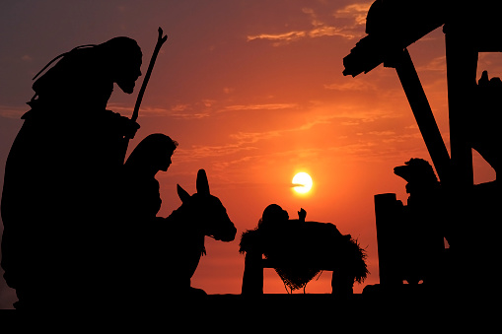

Christmas Greetings to you all
Peace and Joy and Light and Hope
Jesus, the Christ, is born

